**Task - 3**

**Name :** Sujitra M

**Email ID** : [sujiedusport@gmail.com](mailto:sujiedusport@gmail.com)

**Task Title**: Responsive TO-DO App

**Task Description**:

The third task involves developing a responsive TO-DO App using HTML, CSS and JavaScript. The web page includes list of task to be completed and also the status of the task.The primary goal is to utilize HTML, CSS and JavaScript to create the TO-DO App and to design a user-friendly interface that allows users to manage their tasks seamlessly and also responsive across various devices. This project aims to showcase coding skills, creativity, and attention to detail.

**Project Overview:**

1. The project is a single web page containing different task and a text area to add custom tasks. The Add button lets the user to add the task to the list. We can add as many task as we have.
2. We have the facility to check the task in the list, edit them and remove them if we want.
3. We can view the overall task and also filter the task by their status

* All
* Completed
* Uncompleted

**Steps Taken:**

1. **HTML Structure:** Created the HTML structure ensuring semantic markup and accessibility standards. Used Various HTML tags to develop the layout of each element on a web page.
2. **CSS Styling:** Utilized CSS to style the HTML elements according to the design specifications including fonts, colors, backgrounds, spacing, pointer, border alignment.
3. **Responsive Design:** Implemented media queries, Grid and flexible layout techniques to ensure responsiveness across various devices and screen sizes.
4. **JavaScript:** Used JavaScript language to make web page interactive and execute complex actions. It allows us to dynamically update content without reloading the entire page and also used to create clickable Buttons, control multimedia.

**Challenges Faced:**

**Responsive Layout:** Adapting the design to ensure responsiveness across different devices posed a challenge, especially in handling complex layouts and interactions.

**Solutions Implemented:**

Media Queries, Grid and Flexbox Layout Module played a major role to make the web page responsive.

1. **Media Queries:** Implemented media queries to adjust layout and styling based on screen size, ensuring optimal display across devices.
2. **Grid Layout Module:** Implemented Grid Layout Module for space distribution.
3. **Flexbox Layout Module**: Implemented Flexbox Layout Module for arranging items in rows or columns. Flexbox offers space distribution between items and powerful alignment capabilities.

**Learnings:**

1. **HTML Structure:** Learned various HTML tag and its properties.
2. **CSS Techniques:** Learned advanced CSS techniques such as

* **Flexbox Layout Module**: Used Flexbox to streamline page structure and enhance responsiveness.
* **Grid Layout Module**: Also used Flexbox to streamline page structure and enhance responsiveness.
* **Media Queries:** Gained a deeper understanding of responsive design principles and techniques for creating adaptable layouts using Media Queries.
* **Transition:** Used Transition to change property values smoothly over a given duration
* **Text-Transform:** Used to specify uppercase and lowercase letters in a text.
* **Variable:** Used Variables to store and reuse the values and it makes the code more understandable
* **Position:** Used Position property to specify the position an element.

1. **JavaScript:** Learned various JavaScript concept like Objects, Properties, Events Functions, Loops, Closures, Switch Statement, HTML DOM Elements and Methods.

**Project Update:**

The responsive TO-DO Web page has been successfully developed. The web page is developed with Hyper Test Markup Language(HTML), Cascading Style Sheets(CSS) and JavaScript. The page is fully functional and responsive, showcasing the information effectively across various devices and screen sizes.

**Project Images:**

TO DO PROJECT:

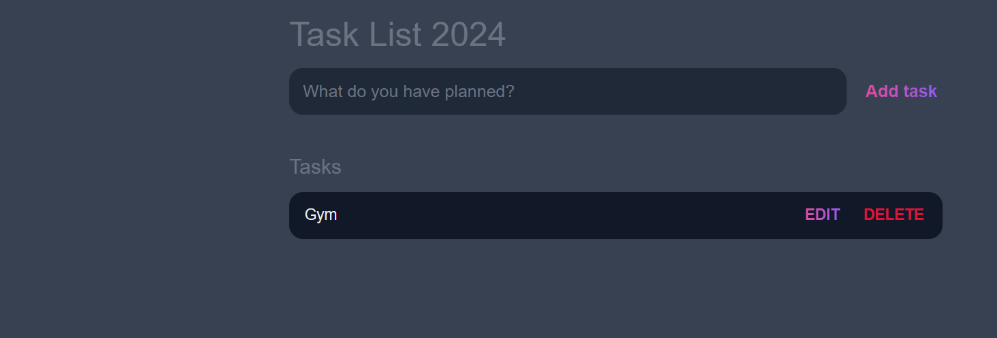

Writing Task,Choosing Category and Submitting the Task using Add button:

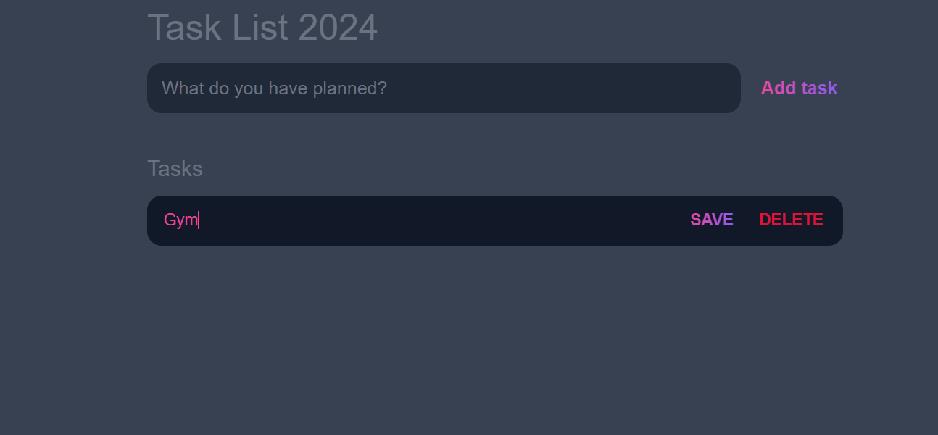

Editing the Task using Edit button:

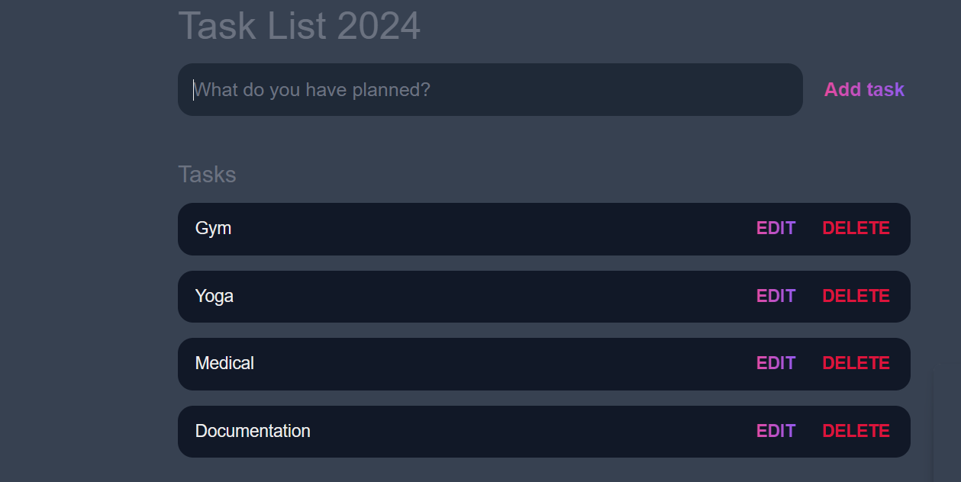

Overall Task:

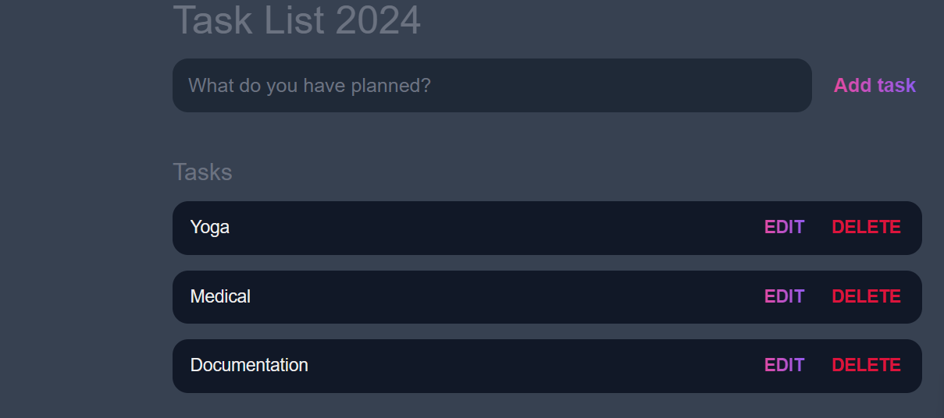

Deleting the Task using delete button:

**Date: 04-04-2024**